**Jenkins Remoting Setup**

• A **Jenkins controller** (On Amazon EC2) with **controller executors disabled** (for safety & isolation).

• **Three remote agents** set up via different methods:

**• agent-ubuntu-docker → for Docker-based builds.**

**• agent-ubuntu-maven → for Java/Maven builds.**

**windows-agent → runs Windows-specific tasks**• A pipeline that **distributes builds** across these agents

• **Security hardening**: least‑privilege user, credentials hygiene, and locked‑down ports.

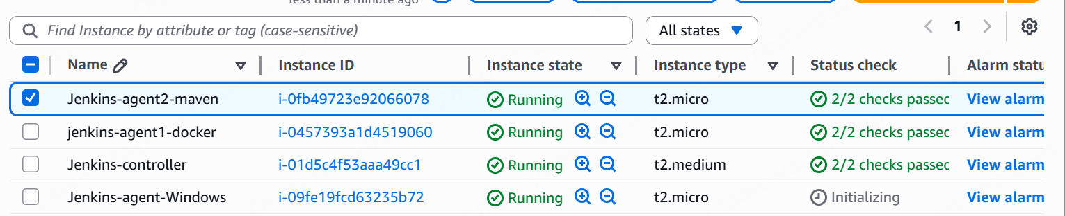

**Phase 1**

Prerequisites & Install Jenkins (Controller)

**Prerequisites.**

* Ubuntu 22.04 LTS on AWS
* Java 17
* Jenkins server

**Steps.**

1. **Launch EC2 Instance.**

• In AWS Console → EC2 → Launch Instance.

• Name: jenkins-controller.

• AMI: Ubuntu 22.04 LTS.

• Instance type: t2.medium

• Security Group:

Allow **22 (SSH)** from your IP.

Allow **8080 (Jenkins web)** from your IP (or 0.0.0.0/0 if testing).

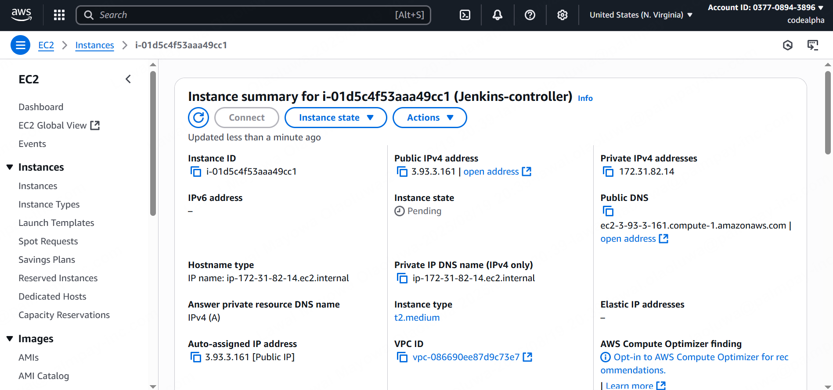

1. **Update packages and install java 17**

Using “sudo apt update”

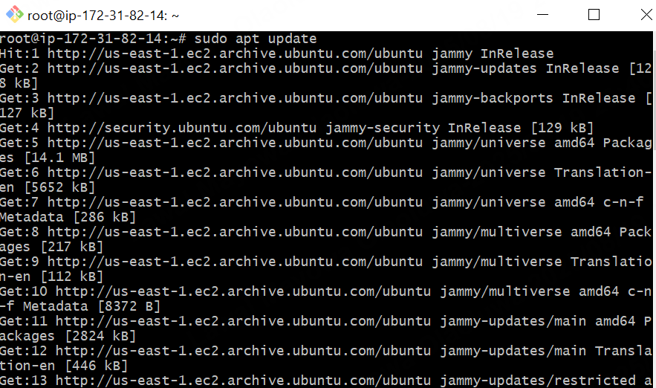

Install java 17

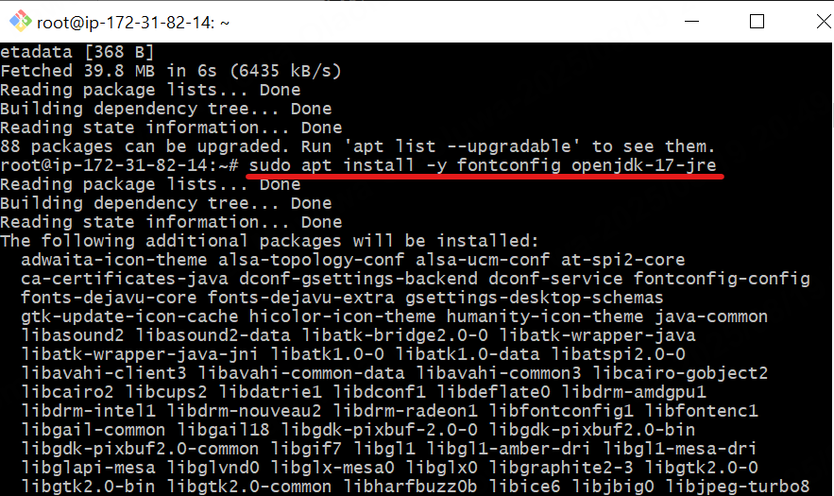

Check java version.

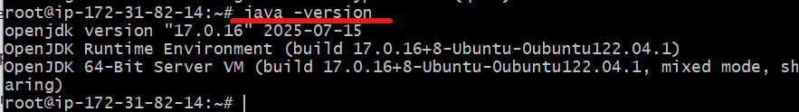

1. **Add Jenkins Repository**

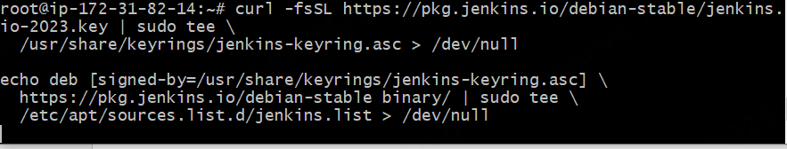

1. **Install Jenkins**

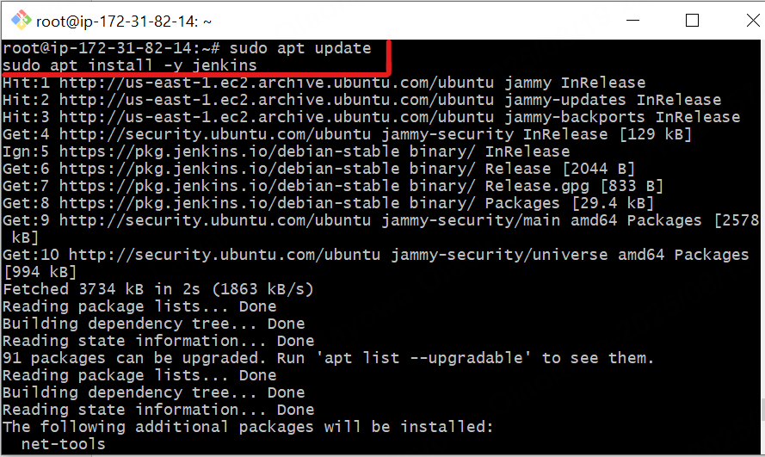

1. **Enable, Start and check Jenkins Status**

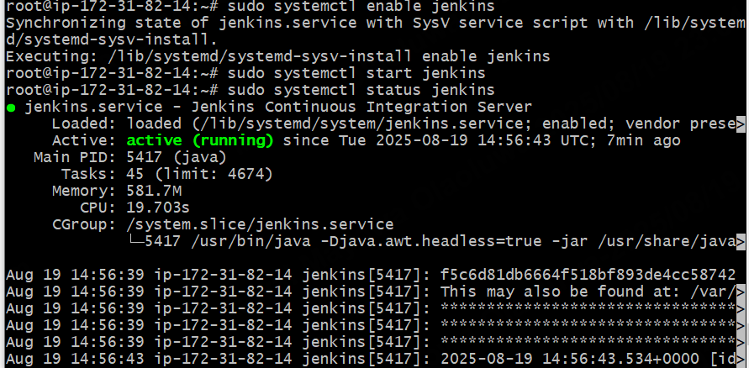

1. **Access Jenkins**

sudo cat /var/lib/jenkins/secrets/initialAdminPassword in CLI for First-time setup:

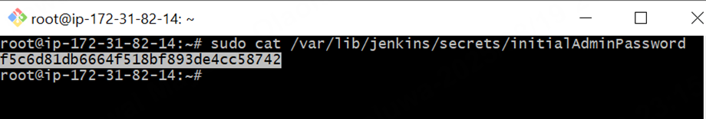

**In browser**: http://<controller-public-ip>:8080

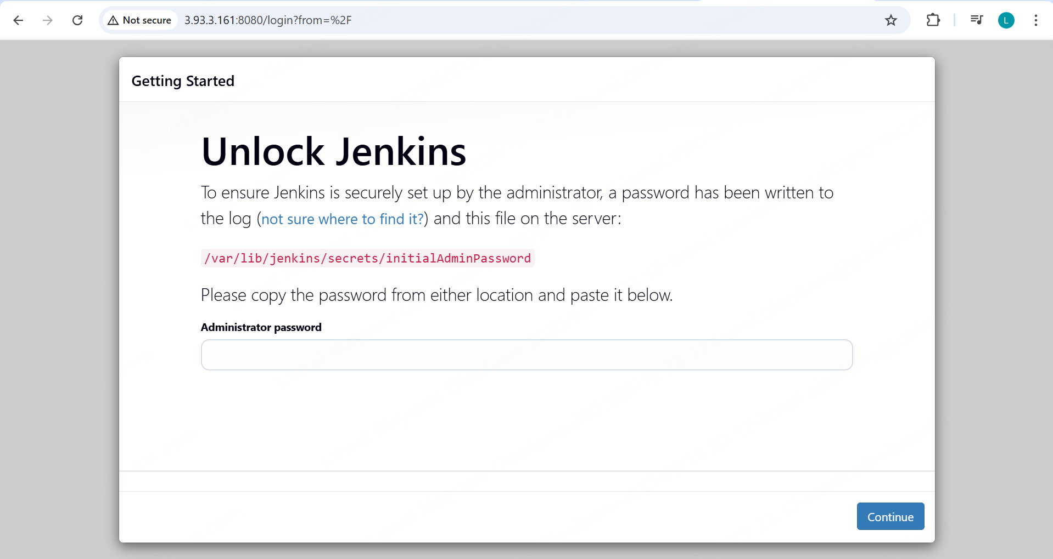

Paste in  **“Administration password”**

**Pick : Install suggested plugins.**

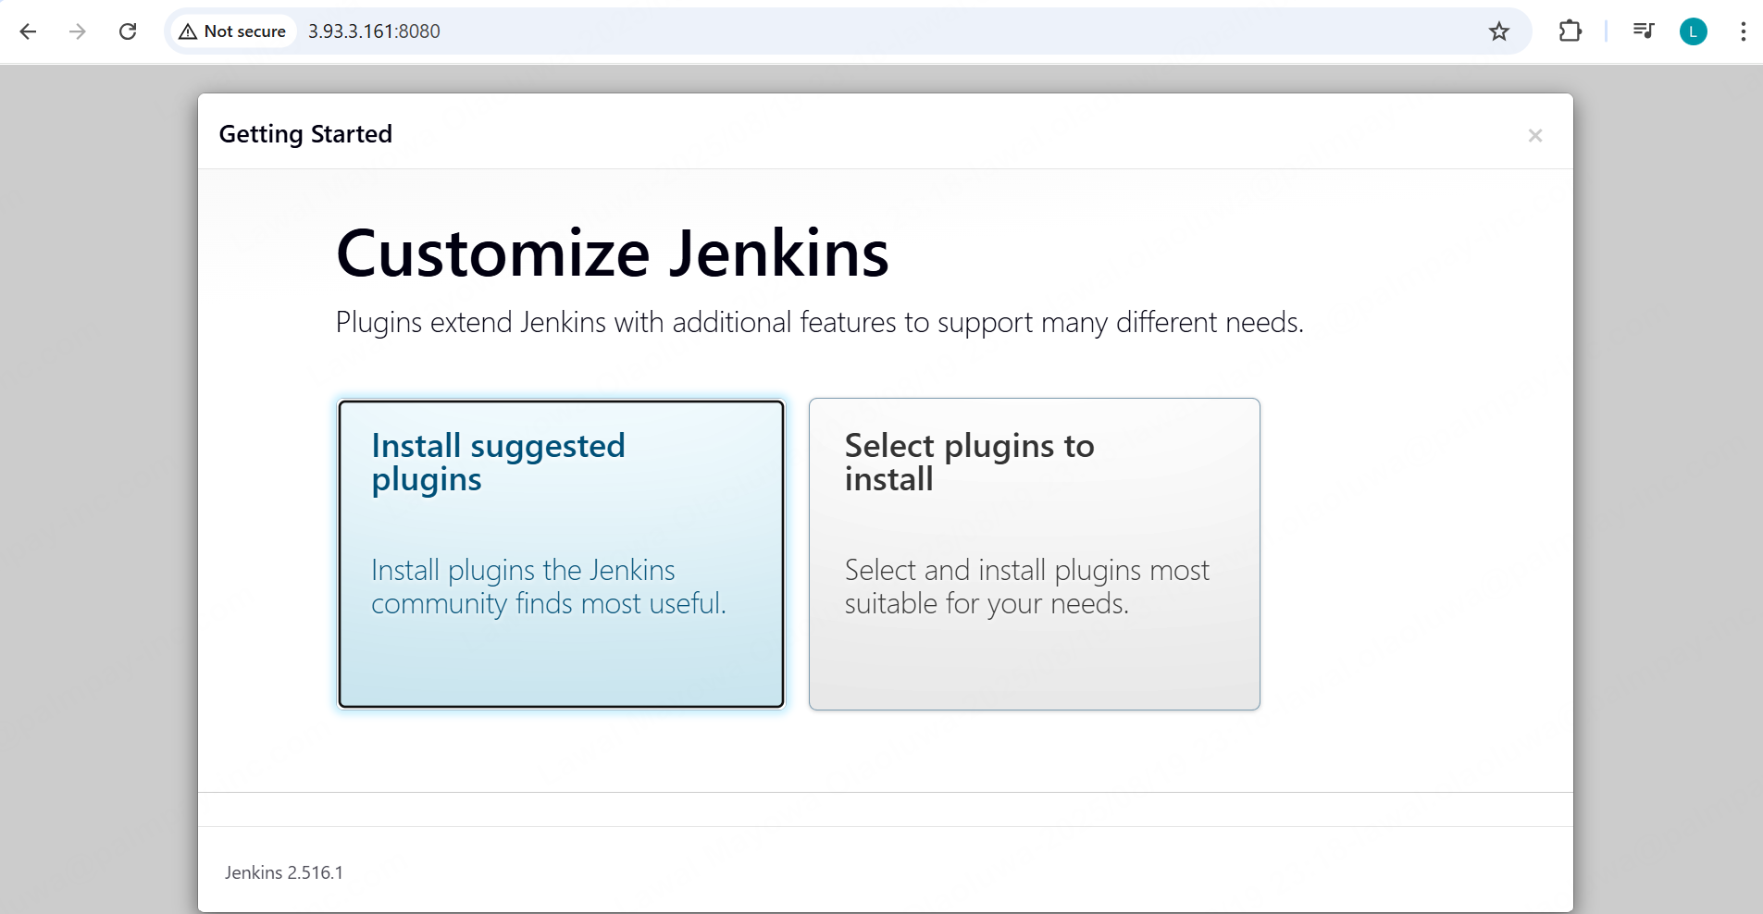

**Phase 2**

**Jenkins Agents Setup**

Option A – SSH-based linux docker Agent.

Steps

1. Prepare the Remote Machine (Agent Node)  
   Ubuntu agent Machine on AWS

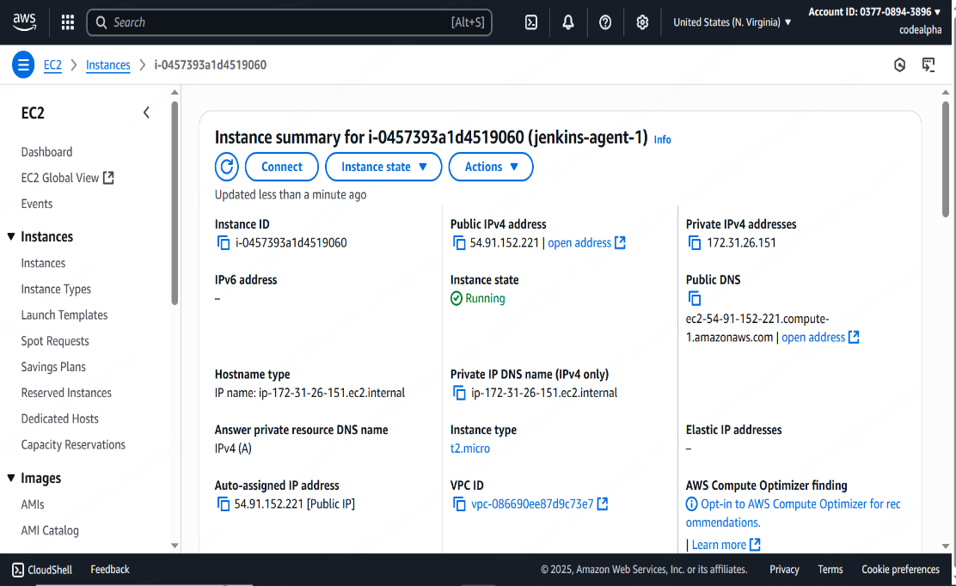

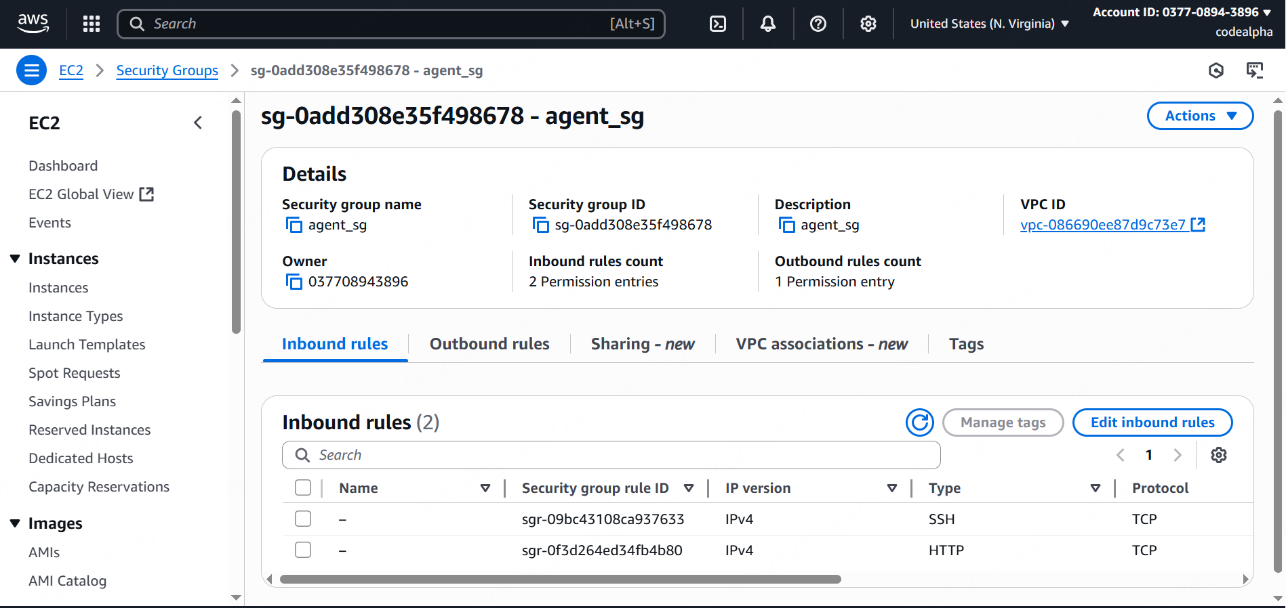

1. Prep into the agent machine and add Jenkins user. And also to Sudo group.

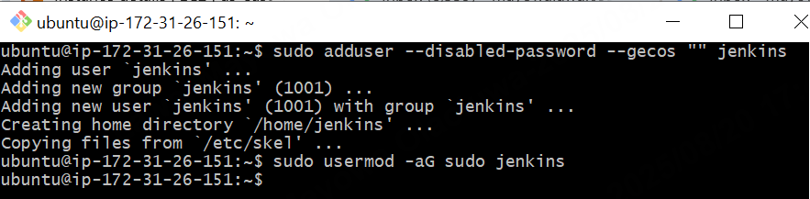

1. Create a clean work dir for Jenkins agent



1. Install Java (OpenJDK 17)

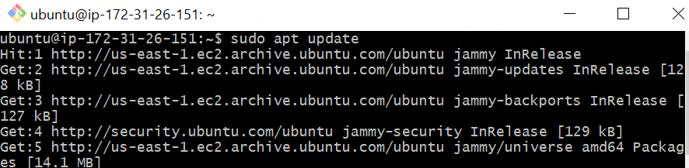

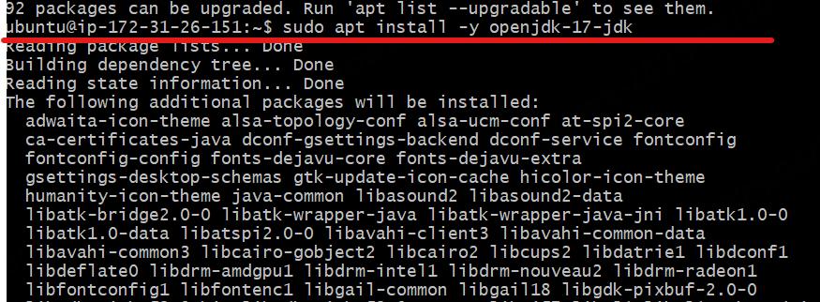

1. Install Docker and enable. (use docker documentation on any of your websites)

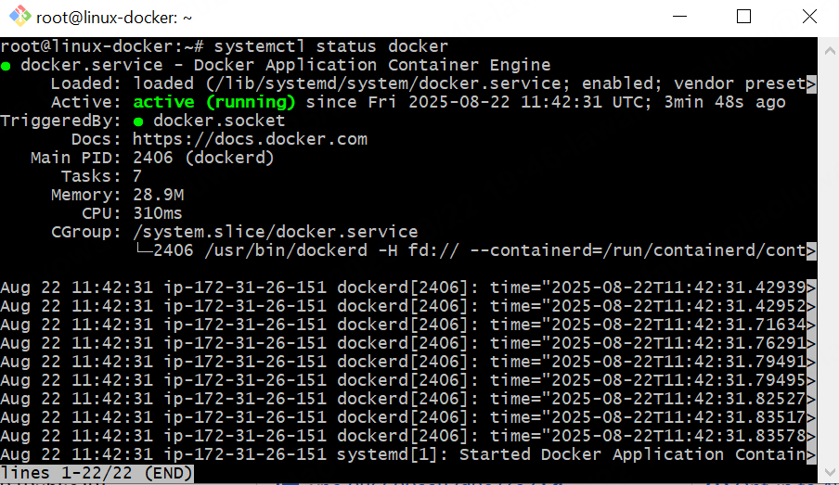

1. Harden SSH a bit (optional but good)

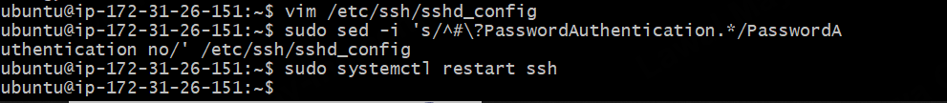

1. Create an SSH key for Jenkins Controller to agent.

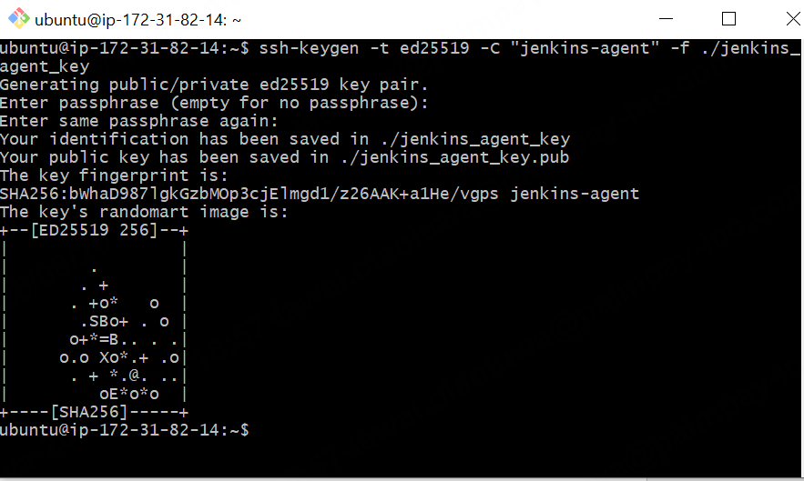

**This creates: jenkins_agent_key (private) and jenkins_agent_key.pub (public)**



1. Add the **public** key to the agent’s jenkins user

* **Copy the public key from controller**

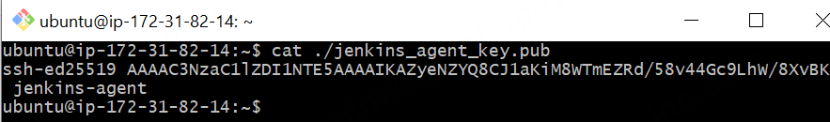

* **Paste in Agent**

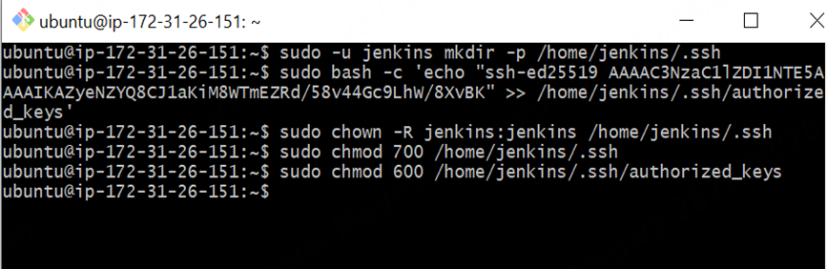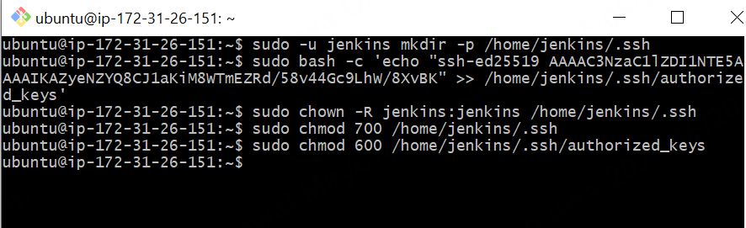

1. Add the private key to Jenkins Controller(UI)

* **Copy private key from Jenkins Controller CLI**

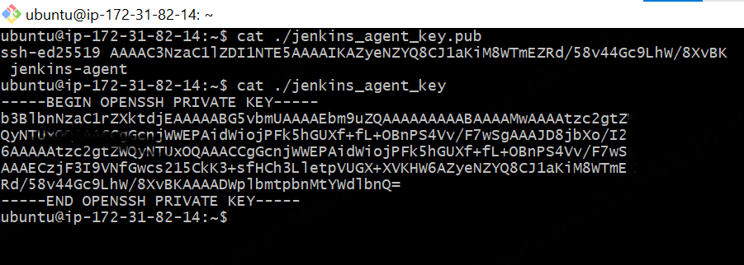

* **Paste in Jenkins Controller UI**

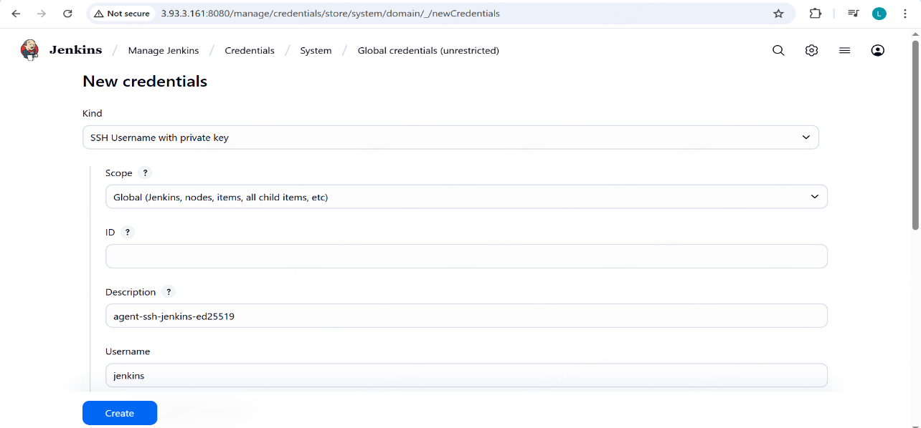

Jenkins → **Manage Jenkins → Credentials → System → Global credentials → Add Credentials**

**Credentials**

**Kind:** SSH Username with private key

**Username:** jenkins

**Private Key:** “Enter directly” → paste contents of jenkins_agent_key

**ID/Description:** agent-ssh-jenkins-ed25519

1. Test SSH manually (from controller)

**ssh -i ./jenkins_agent_key jenkins@<AGENT_IP> "whoami && hostname && java -version"**

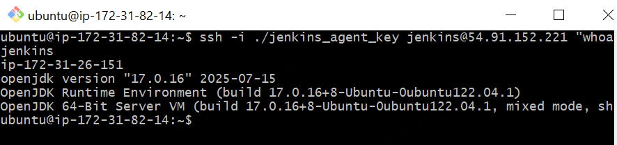

1. Add Remote Node in Jenkins UI

* Create Node

Jenkins dashboard→ **Manage Jenkins**→ Nodes →click new Node→ Input name and select permanent agent→ Create

* Configure Node Details

**Name**: agent-ubuntu-docker

**# of executors**: 1

**Remote root directory**: /home/jenkins/agent

**Labels**: linux-docker

**Usage**: Only build jobs with label expressions

**Launch method:** Launch agents via SSH

**Host:** Agent Private IP

**Credentials**: agent-ssh-jenkins-ed25519

**Host Key Verification Strategy**: Manually trusted key verification once

**Availability:** Keep this agent online as much as possible

**Save and Connect**

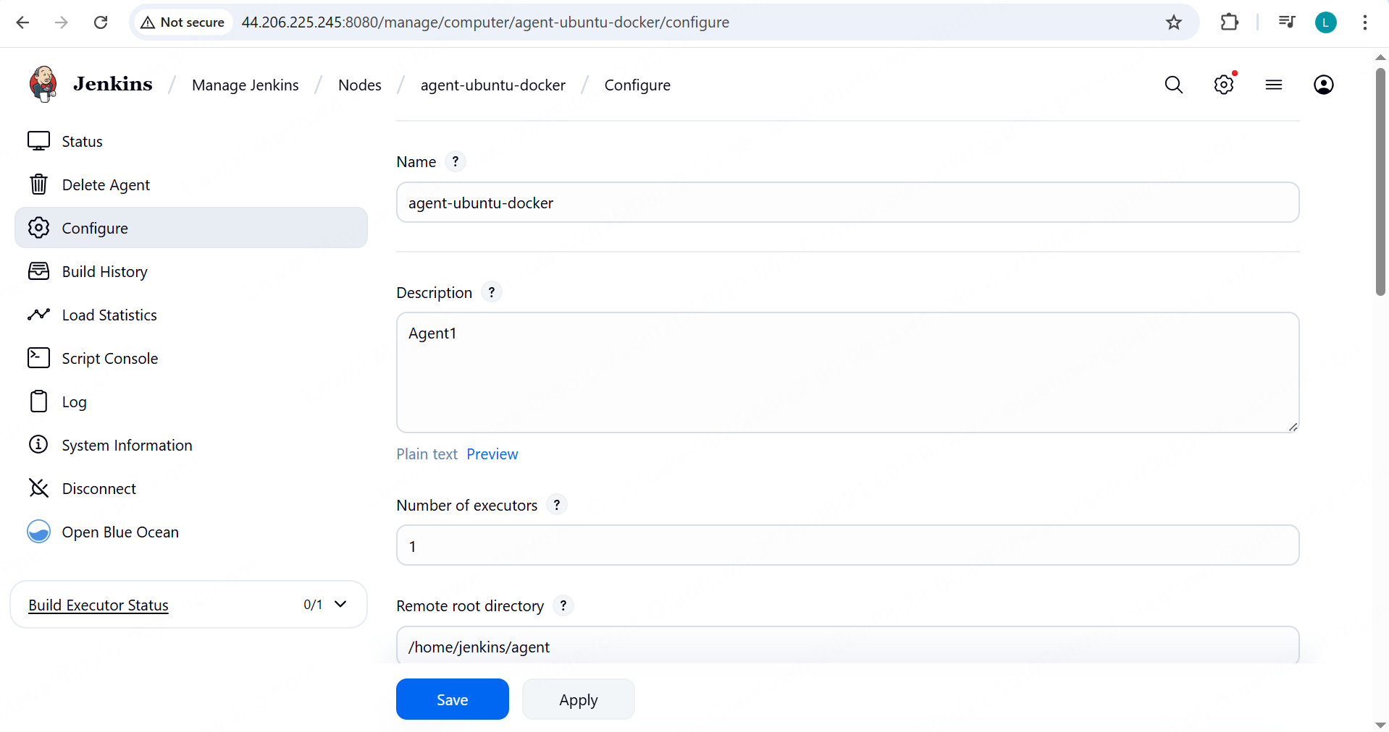

**Test successful**

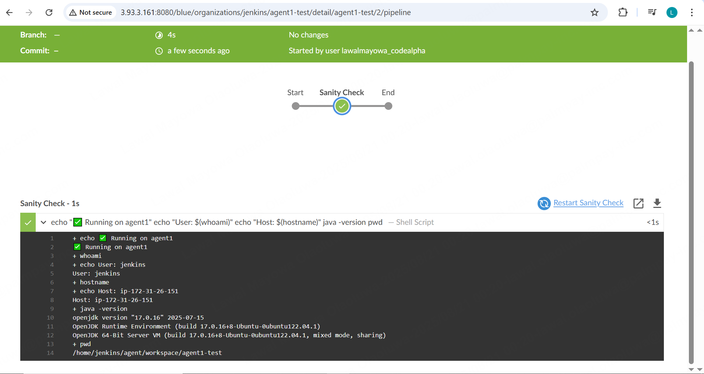

**Second agent**

linux-maven (Ubuntu 22.04)

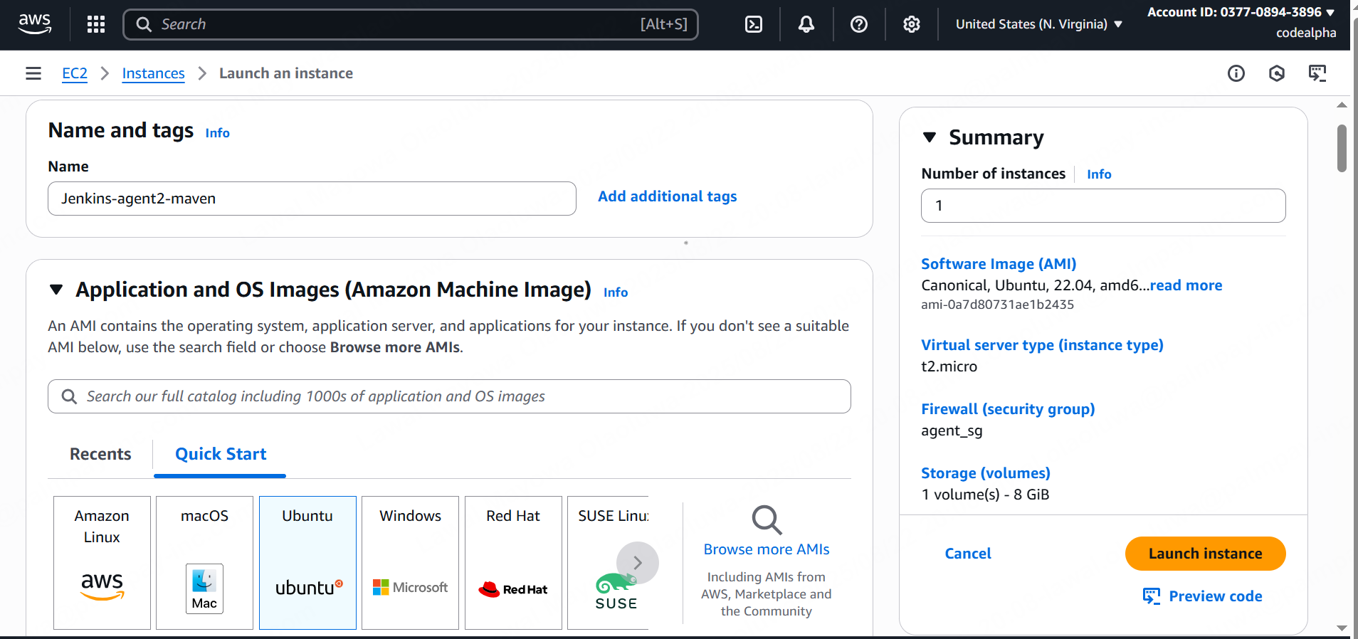

**Ssh to the linux-maven agent ( the second agent).  
  
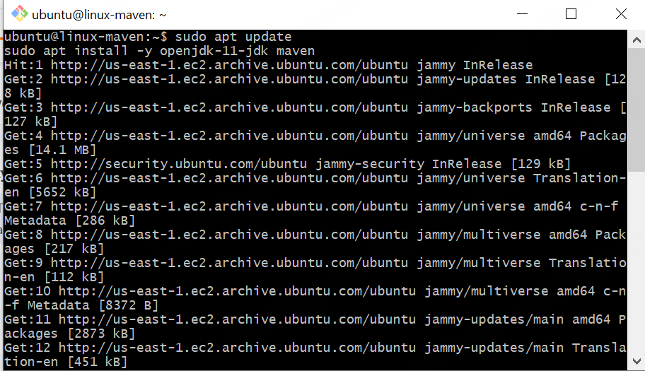**

**Update** and install **open jdk** and **Maven.**

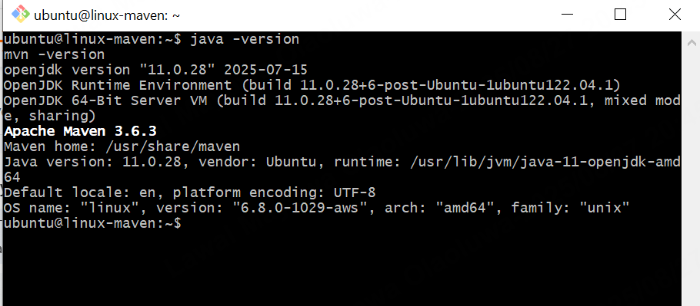

**Check jdk and Maven Version.**

**Create Jenkins User on EC2**

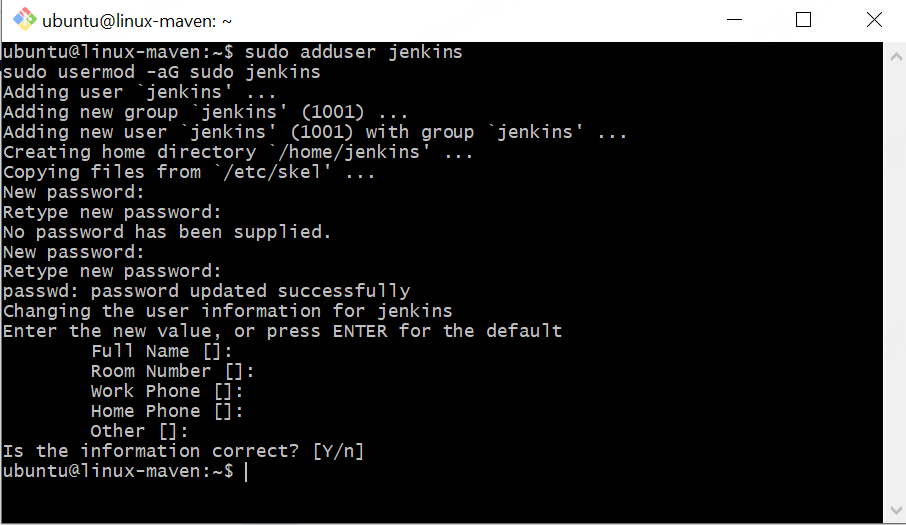

**Password:** admin

**Set Up SSH from Jenkins Controller**

* **On your Jenkins Controller:**

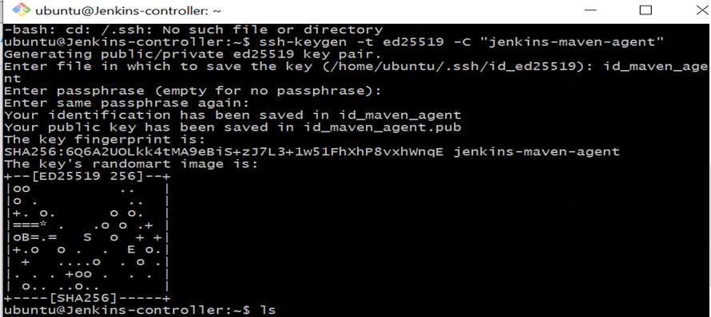

**Creating another key pair for ssh login for the second agent.**

* **Copy Public Key from Controller to Maven Agent EC2**

**Copy from the Jenkins controller**

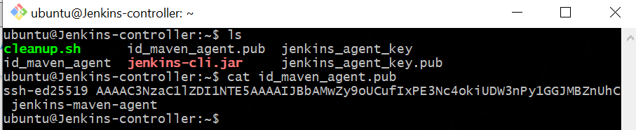

**Paste the public key in agent.**

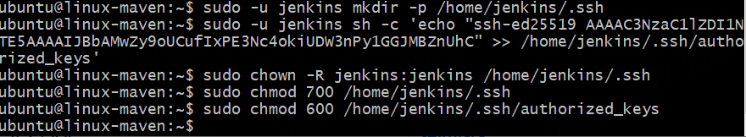

**Test remove login**

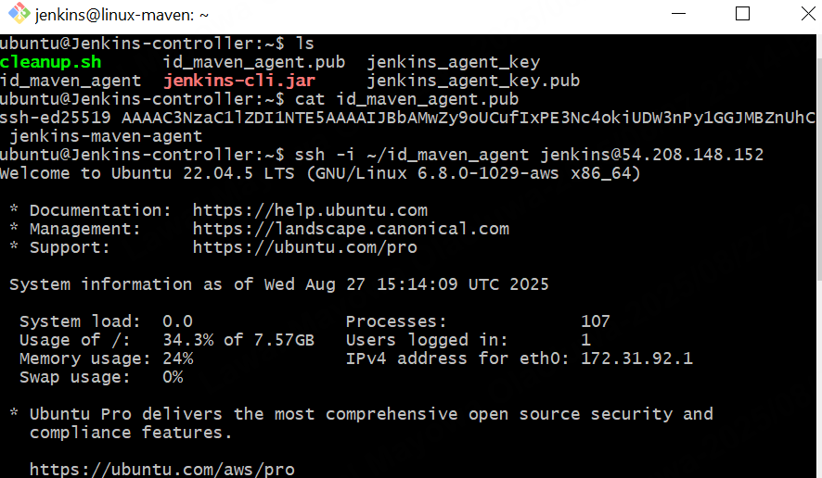

**Successful: Controller Jenkins can login maven Jenkins agent.**

* **Paste private key From Cli to Jenkins UI (see example 1)**

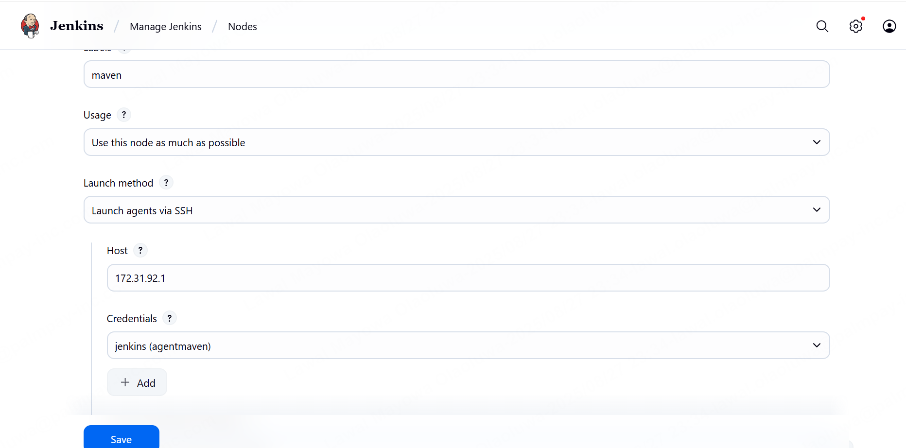

**Go to Manage Jenkins → Nodes → New Node.**

**Enter a name (e.g., maven-agent), select Permanent Agent, then click OK.**

**Configure the node:**

**Remote root directory: /home/jenkins**

**Labels:** maven (this helps when targeting the agent in a pipeline).

**Usage:** "Use this node as much as possible".

**Launch method:** Select Launch agents via SSH.

**Host:** Use the private IP of the Maven Agent instance.

**Credentials:**

**Add credentials** (kind = SSH Username with private key).

**Username =** jenkins (the one you set up on the agent).

**Private key =** paste the private key that matches the public key in the agent’s authorized_keys.

**Host Key Verification Strategy →** set to “Non verifying”   
  
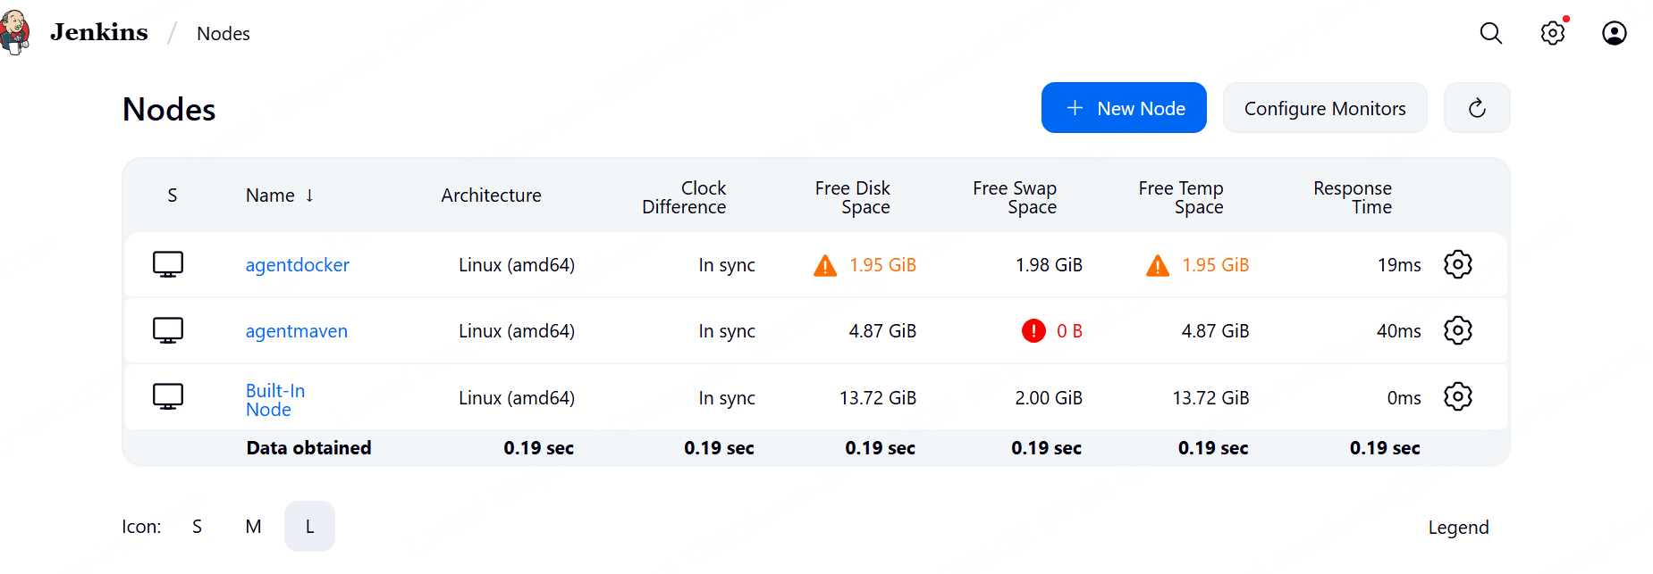Node configure.

Test Node

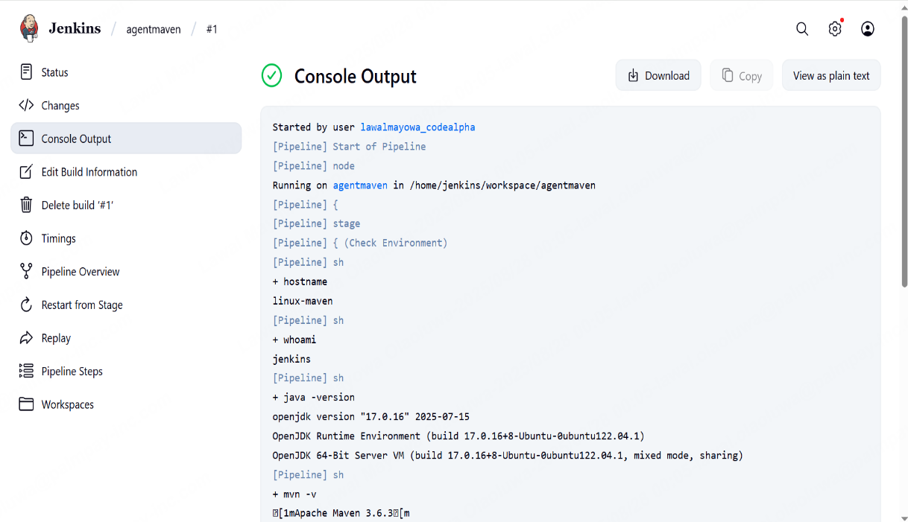

Test successful.

**Third Agent**

**agent-windows → for Windows builds & PowerShell/.NET jobs.**

* Launch an EC2 windows instance on Aws

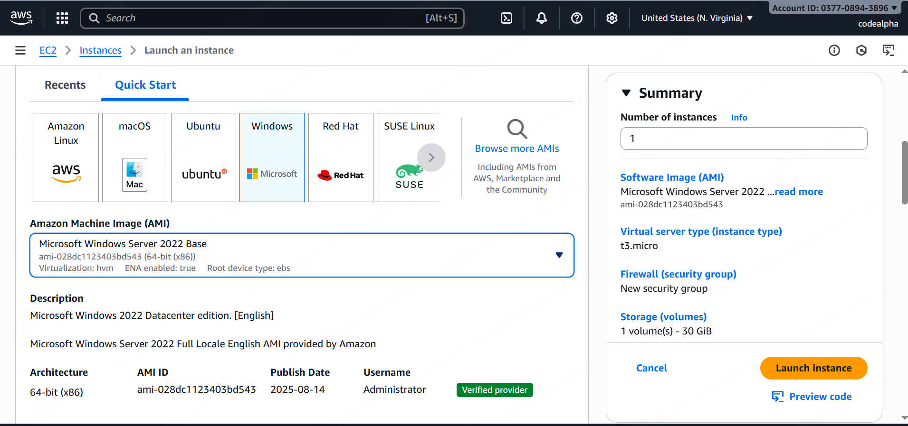

* Allow RDP (TCP 3389) from your IP for remote login.

Allow outbound TCP to Jenkins controller IP on port 8080 (or HTTPS).

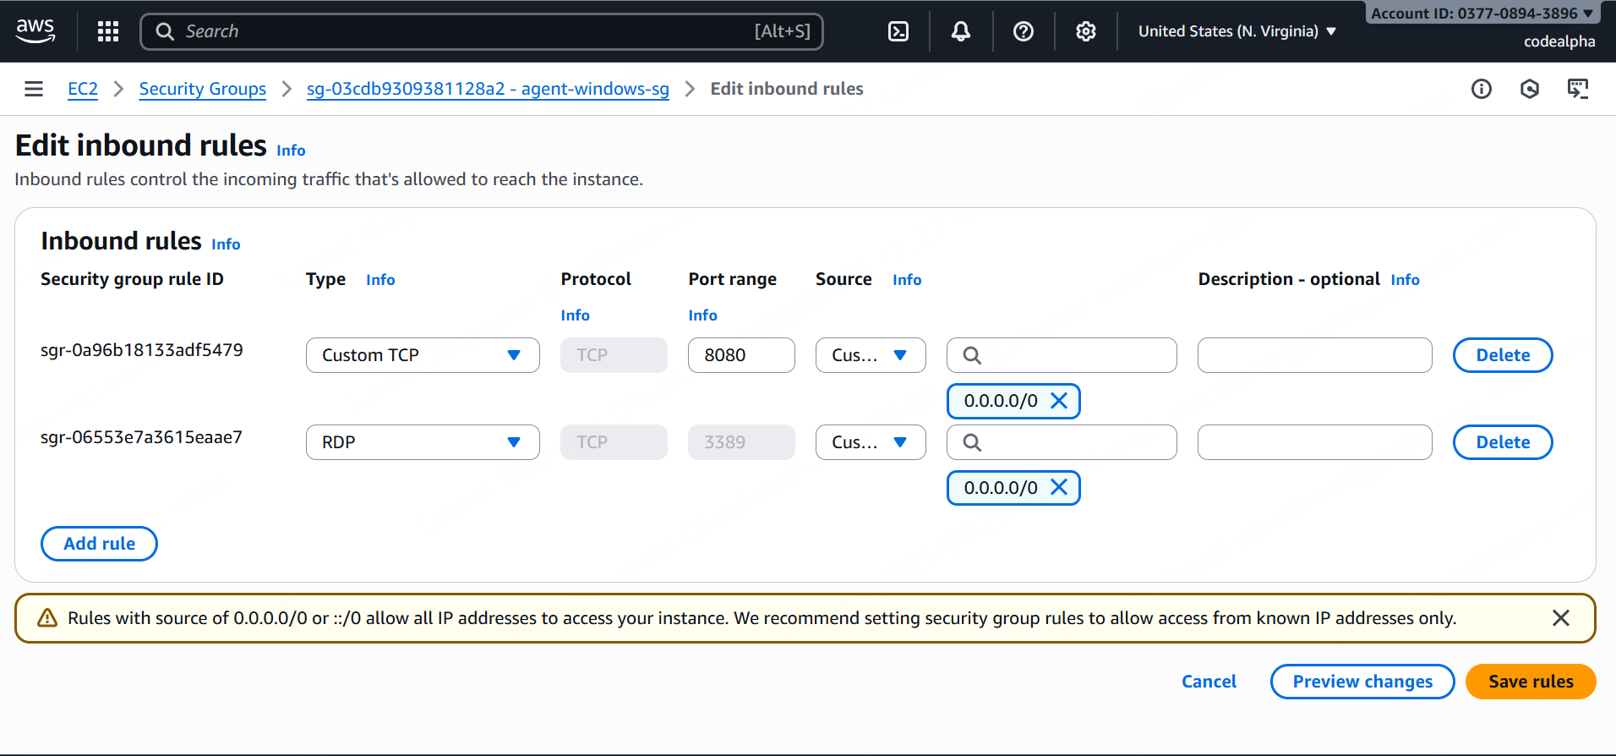

* Log in via RDP using the key pair.

AWS Management Console → EC2 → Instances→ **Windows EC2 instance**→ Connect → RDP client→ get password→ Upload your **private key (.pem)** → Decrypt password

You’ll see the **Administrator password** (copy it securely)

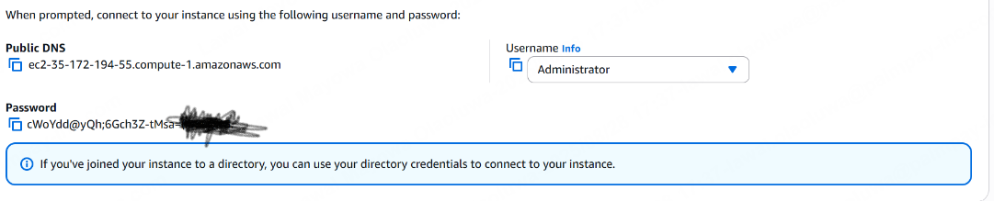

* Open **Remote Desktop Connection (RDP)** on your local machine and paste the dns of the EC2 and the saved password

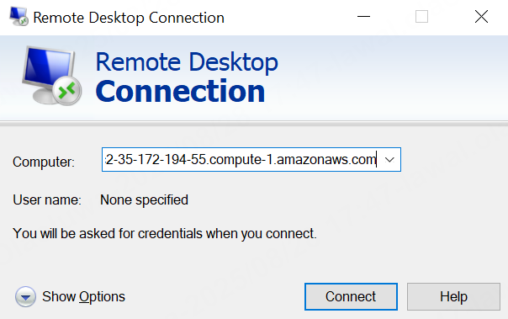

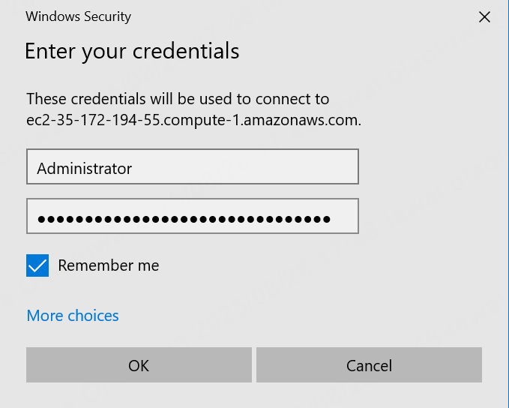

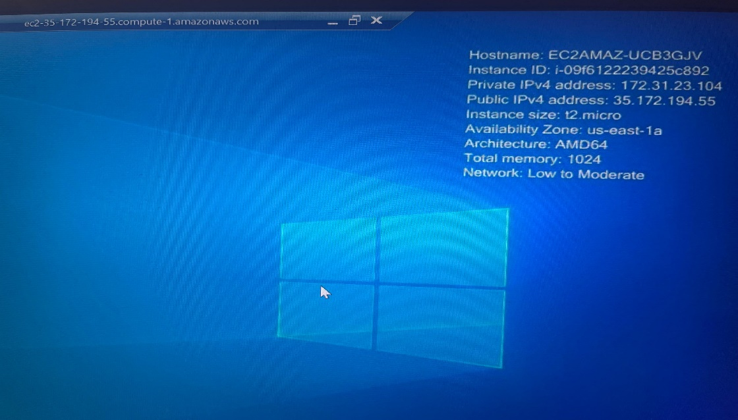

Connected successfully

* Prepare Windows Agent for Jenkins

Computer Management → Local Users and Groups → Users → New User

Username: Jenkins

Password: admin

Add the user to **Administrators group (using powershell)**

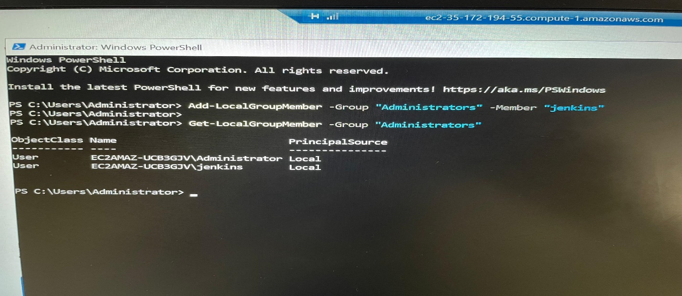

* **Create a folder for Jenkins agent files**:
* **Install Java 17**

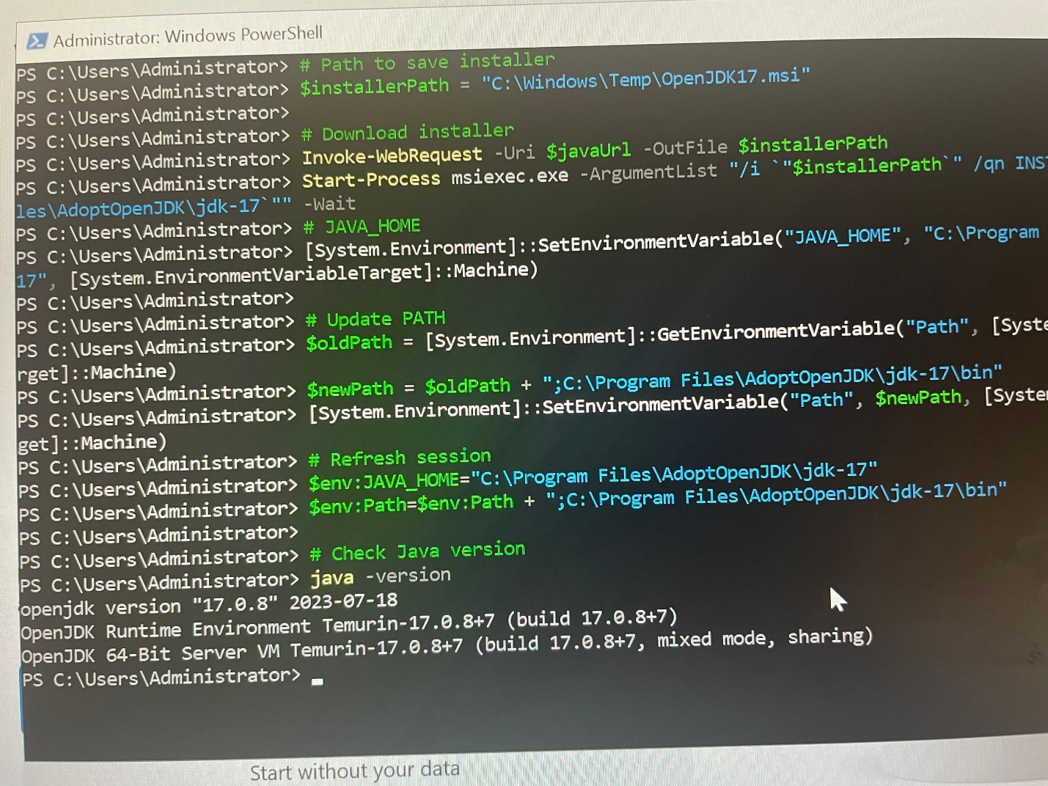

* **Add Windows Node in Jenkins Controller**

**Node Name:** windows-agent

**Type:** Permanent Agent

**Remote Root Directory:** C:\jenkins

**Labels:** windows

**Usage:** Only build jobs with label expressions matching this node

**Launch Method:** Launch agent via Java Web Start (JNLP)

* Go to the Node Page in Jenkins  
    
  Navigate to **Manage Jenkins → Manage Nodes and Clouds → your Windows agent node→** Click on the **node name** to open its page

**Make it permanent**

Stop the current running agent

* **Download WinSW (Windows Service Wrapper)**

**Place it in your Jenkins work directory:**

**cd C:\jenkins**

**Invoke-WebRequest -Uri https://github.com/winsw/winsw/releases/latest/download/WinSW-x64.exe -OutFile C:\jenkins\jenkins-agent.exe**

* **Create a service config file  
  In the same folder (C:\jenkins), create jenkins-agent.xml with:**

**<service>**

**<id>jenkins-agent</id>**

**<name>Jenkins Agent</name>**

**<description>Jenkins Agent running as a Windows Service</description>**

**<executable>java</executable>**

**<arguments>-jar C:\jenkins\agent.jar -url http://3.91.80.33:8080/ -secret 8d1cc3b954acd87d8b7e73609859d5e76676f8251bc14c8d945c2a8c78446526 -name windows-agent -workDir C:\jenkins -webSocket</arguments>**

**<logpath>C:\jenkins\logs</logpath>**

**<log mode="roll"></log>**

**</service>**

* **Install the service**

**.\jenkins-agent.exe install**

* **Start the service**

**.\jenkins-agent.exe start**

* **Verify**

**Get-Service jenkins-agent**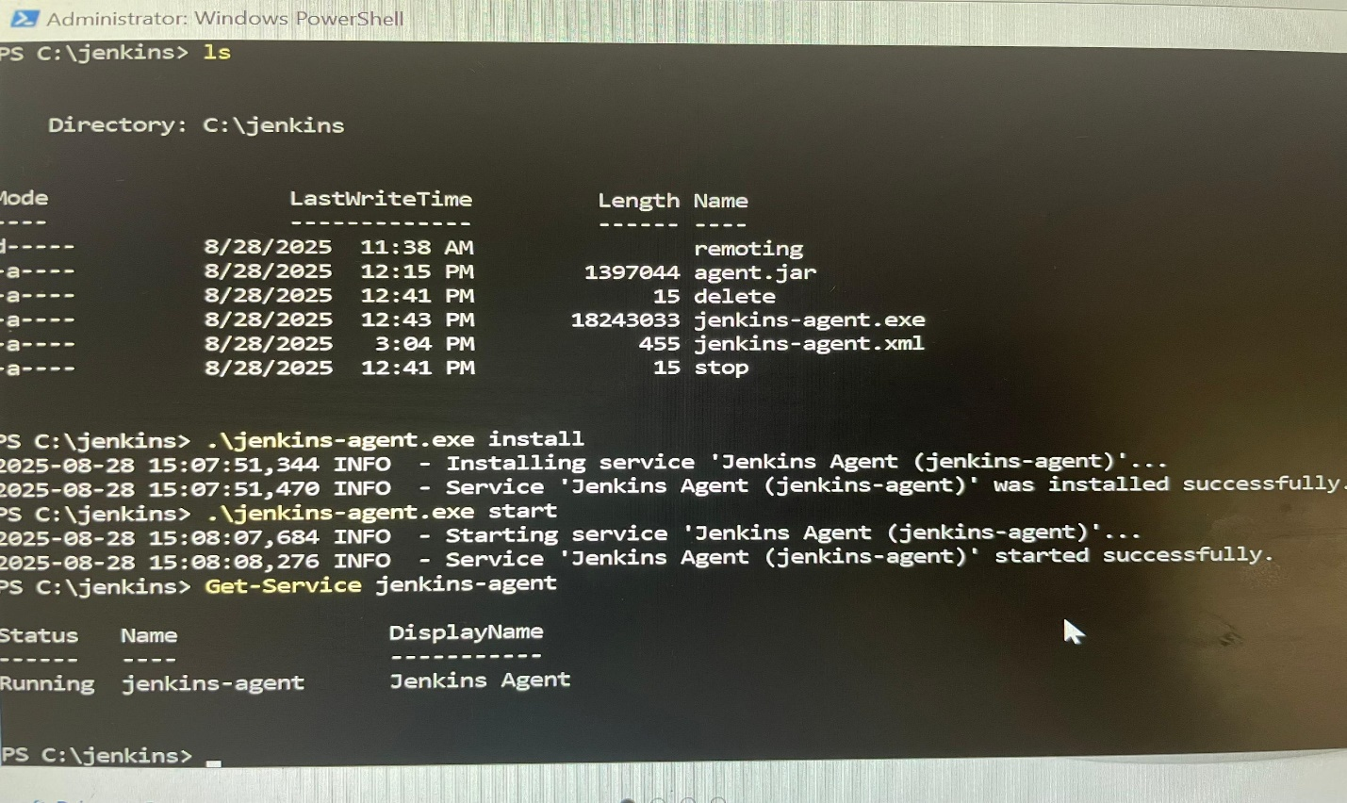

**Jenkins agent running successfully.**

**All Agents running successfully.**

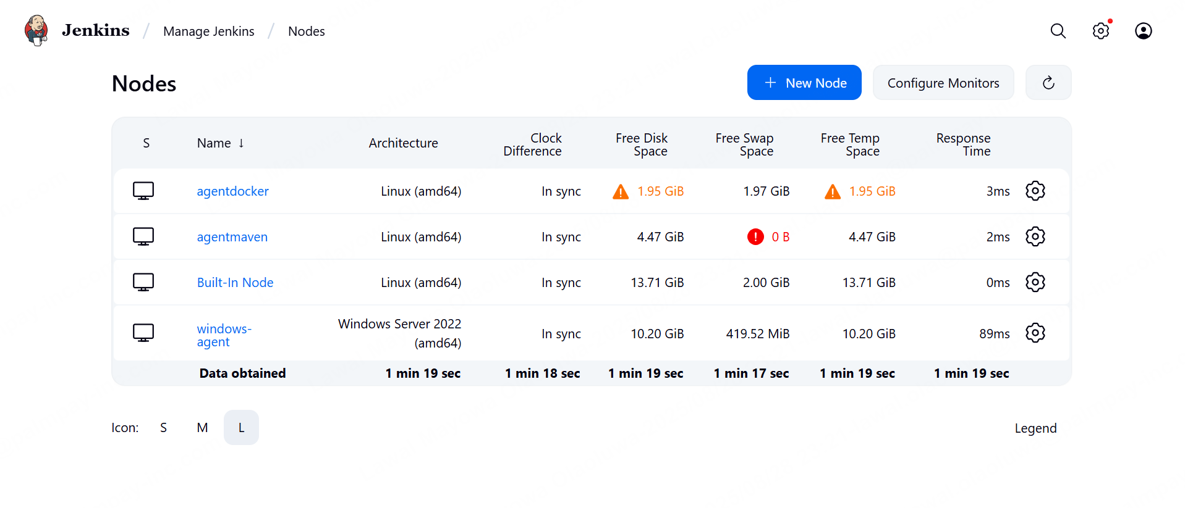

**REMOTE JENKIN SCRIPT.**

* **agentmaven → builds Java with Maven**
* **windows-agent → runs Windows-specific tasks**
* **agentdocker → builds & deploys Docker images**

**Stage 1: Build with Maven**

stage('Build with Maven') {

agent { label 'agentmaven' } // Run only on Maven agent

steps {

git branch: 'main', url: 'https://github.com/spring-projects/spring-petclinic.git'

sh 'mvn clean package -DskipTests'

stash includes: 'target/*.jar', name: 'app-jar'

}

}

**Stage 2: (Tests skipped)**// stage('Test with Maven') { ... }

**Stage 3: Run on Windows Agent**

stage('Run on Windows Agent') {

agent { label 'windows' } // Runs on Windows node

steps {

echo "Running a task on the Windows agent..."

bat 'echo Hello from Windows Agent > windows_task.txt'

bat 'type windows_task.txt'

}

post {

always {

archiveArtifacts artifacts: 'windows_task.txt', fingerprint: true

echo "Windows agent task output archived."

}

}

}

**Stage 4: Docker Build & Push**

stage('Docker Build & Push') {

agent { label 'agentdocker' } // Runs on Docker-capable agent

steps {

unstash 'app-jar' // Get back the JAR built on Maven agent

// Create Dockerfile and copy app.jar

sh '''

cp target/*.jar app.jar

echo "FROM openjdk:11-jre-slim" > Dockerfile

echo "COPY app.jar /app.jar" >> Dockerfile

echo 'ENTRYPOINT ["java","-jar","/app.jar"]' >> Dockerfile

'''

// Build & push to Docker Hub

withCredentials([usernamePassword(credentialsId: 'dockerhub-creds', usernameVariable: 'USER', passwordVariable: 'PASS')]) {

sh '''

docker build -t $USER/jenkinsjob:latest .

echo $PASS | docker login -u $USER --password-stdin

docker push $USER/jenkinsjob:latest

'''

}

}

}

**Stage 5: Deploy on Docker Agent**

stage('Deploy on Docker Agent') {

agent { label 'agentdocker' }

steps {

sh '''

docker stop jenkinsjob || true

docker rm jenkinsjob || true

docker run -d --name jenkinsjob -p 8080:8080 pmayors/jenkinsjob:latest

'''

}

}

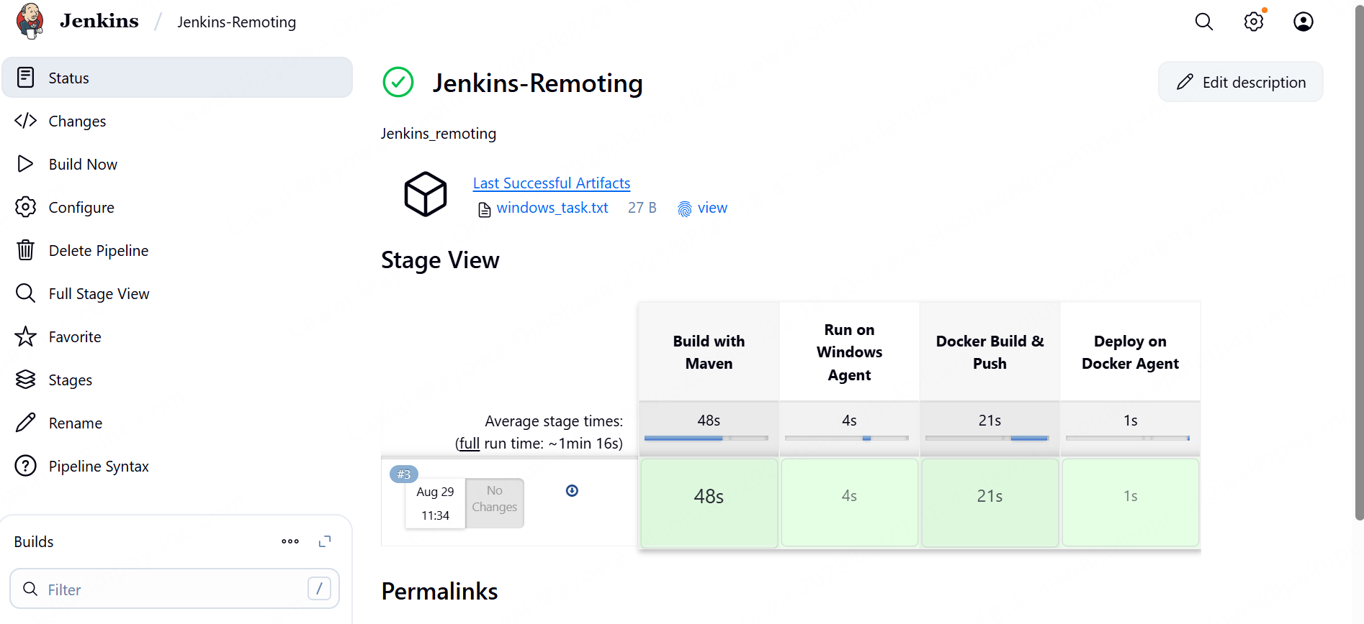  
  
  
FULL JENKINS FILE.  
  
pipeline {

agent none

environment {

DOCKER_IMAGE = "pmayors/jenkinsjob:latest"

}

stages {

stage('Build with Maven') {

agent { label 'agentmaven' }

steps {

// Pull Spring PetClinic project from GitHub (public repo)

git branch: 'main', url: 'https://github.com/spring-projects/spring-petclinic.git'

// Build the project (skip tests)

sh 'mvn clean package -DskipTests'

// Save jar artifact for later stages

stash includes: 'target/*.jar', name: 'app-jar'

}

}

// Skipping Test stage as per your setup

// stage('Test with Maven') {

// agent { label 'agentmaven' }

// steps {

// sh 'mvn test'

// }

// post {

// always {

// junit 'target/surefire-reports/*.xml'

// }

// }

// }

stage('Run on Windows Agent') {

agent { label 'windows' }

steps {

echo "Running a task on the Windows agent..."

bat 'echo Hello from Windows Agent > windows_task.txt'

bat 'type windows_task.txt'

}

post {

always {

// Archive the output from Windows agent for verification

archiveArtifacts artifacts: 'windows_task.txt', fingerprint: true

echo "Windows agent task output archived."

}

}

}

stage('Docker Build & Push') {

agent { label 'agentdocker' }

steps {

// Retrieve the JAR file from Maven build

unstash 'app-jar'

// Create Dockerfile dynamically (Java 17 & correct jar name)

sh '''

cp target/spring-petclinic-*.jar app.jar

echo "FROM openjdk:17-jdk-slim" > Dockerfile

echo "COPY app.jar /app.jar" >> Dockerfile

echo 'ENTRYPOINT ["java","-jar","/app.jar"]' >> Dockerfile

'''

// Build and push Docker image

withCredentials([usernamePassword(credentialsId: 'dockerhub-creds', usernameVariable: 'USER', passwordVariable: 'PASS')]) {

sh '''

docker build -t $DOCKER_IMAGE .

echo $PASS | docker login -u $USER --password-stdin

docker push $DOCKER_IMAGE

'''

}

}

}

stage('Deploy on Docker Agent') {

agent { label 'agentdocker' }

steps {

// Stop & remove old container if it exists, then run new one

sh '''

docker stop jenkinsjob || true

docker rm jenkinsjob || true

docker run -d --name jenkinsjob -p 8080:8080 $DOCKER_IMAGE

echo "=== Running Containers ==="

docker ps

echo "=== Last 50 container logs ==="

docker logs --tail=50 jenkinsjob || true

'''

}

}

}

}

**📂 Execution Flow**

1. **Build on agentmaven**
   * Pulled Spring PetClinic from GitHub.
   * Compiled JAR using Maven (skipping tests).
   * Stashed artifact for later stages.
2. **Run task on Windows agent**
   * Executed a batch script (echo Hello from Windows Agent).
   * Archived output file.
3. **Docker build & push on agentdocker**
   * Unstashed JAR.
   * Created Dockerfile dynamically.
   * Built and pushed image to **Docker Hub** using Jenkins credentials.
4. **Deploy on agentdocker**
   * Stopped old container (if running).
   * Deployed new container from latest Docker image.
   * Published on port **8080**.

